* 5.1.1 Data Anomalies
* Consider the following form:
* discuss possible insert, update and delete anomalies based on the above form.

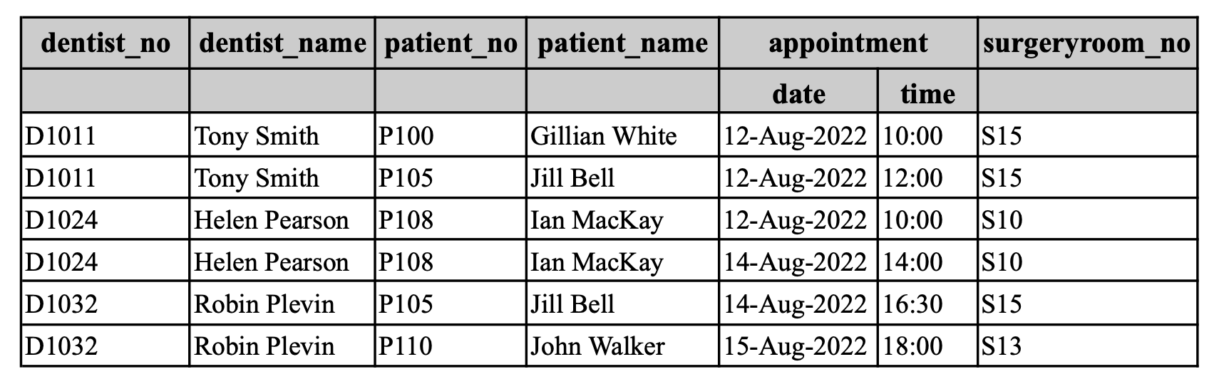**Insertion anomalies**

**When inserting data, you have to insert NULL values to simply add a specific attribute.**

* If there is a new dentist, and you are required to enter into the table, the database manager will have to also input the patient name and a required appointment.

**Update anomalies**

There are unnecessary copies of data everywhere (e.g: dentist name Tony Smith shows up more than once). To solve this you have a data table with dentist names and all you have to change the name there to reflect the change in all databases.

* If you were to update a singular cell in the table then you would have to update it for the rest.
  + E.g: Updating the patient name Ian MacKay, you would have to change it for the rest of the table to keep data consistency.

**Delete anomalies**

**When you want to delete something, you have to get rid of other kinds of data that you don’t want to remove. Delete separate columns, will not affect each other.**

* If you delete the last row you remove the patient name John Walker resulting in the patient name to be completely removed from the database.